**ASP.NET WITH C#.**

**MINDTECK_ 26-08-2022 -**

**Q1. Create an application which will ask the user to input his name and a message, display**

**the two items concatenated in a label, and change the format of the label using radio buttons**

**and check boxes for selection , the user can make the label text bold ,underlined or italic and**

**change its color . include buttons to display the message in the label, clear the text boxes and**

**label and exit.**

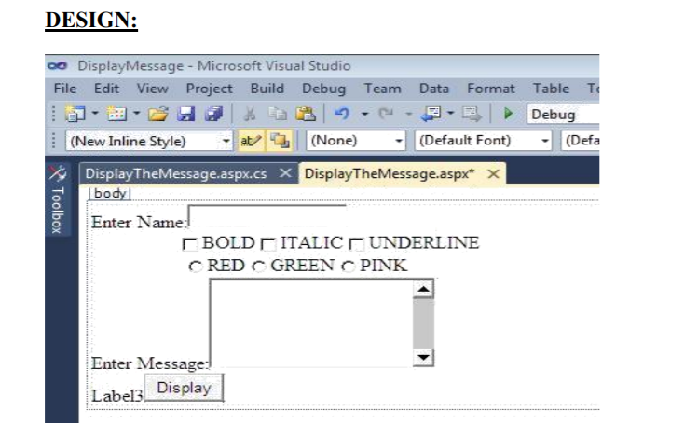

**Ans:-aspx File**

**------------------------------------------------------------------------------------------------------------------🡪>>>**

<%@ Page Language="C#" AutoEventWireup="true" CodeBehind="assign1.aspx.cs" Inherits="assign1.assign1" %>

<!DOCTYPE html>

<html xmlns="http://www.w3.org/1999/xhtml">

<head runat="server">

<title></title>

</head>

<body>

<form id="form1" runat="server">

<div>

<asp:Label ID="Label1" runat="server" Text="Enter Your Name"></asp:Label>

&nbsp;<asp:TextBox ID="txtname" runat="server"></asp:TextBox>

<br />

&nbsp;&nbsp;&nbsp;&nbsp;&nbsp;&nbsp;&nbsp;&nbsp;&nbsp;&nbsp;&nbsp;&nbsp;&nbsp;&nbsp;&nbsp;&nbsp;&nbsp;&nbsp;&nbsp;&nbsp;&nbsp;&nbsp;&nbsp;&nbsp;&nbsp;&nbsp;&nbsp;&nbsp;

<asp:CheckBox ID="txtbold" runat="server" Text="Bold" />

&nbsp;

<asp:CheckBox ID="textitalic" runat="server" Text="ITALIC" />

&nbsp;<asp:CheckBox ID="txtunderline" runat="server" Text="UNDERLINE" />

<br />

&nbsp;&nbsp;&nbsp;&nbsp;&nbsp;&nbsp;&nbsp;&nbsp;&nbsp;&nbsp;&nbsp;&nbsp;&nbsp;&nbsp;&nbsp;&nbsp;&nbsp;&nbsp;&nbsp;&nbsp;&nbsp;&nbsp;&nbsp;&nbsp;&nbsp;&nbsp;&nbsp;&nbsp;&nbsp;

<asp:RadioButton ID="txtred" runat="server" Text="RED" />

&nbsp;<asp:RadioButton ID="txtgreen" runat="server" Text="GREEN" />

&nbsp;<asp:RadioButton ID="txtpink" runat="server" Text="PINK" />

</div>

<asp:Label ID="textmesege" runat="server" Text="Enter Your Message"></asp:Label>

&nbsp;<asp:TextBox ID="txtmsg" runat="server" TextMode="MultiLine"></asp:TextBox>

<br />

<asp:Label ID="txtlbl" runat="server" Text="Label3"></asp:Label>

&nbsp;

<asp:Button ID="btndsp" runat="server" Text="Display" OnClick="btndsp_Click" />

</form>

</body>

</html>

**Aspx.cs**

**-----------------------------------------------------------------------------------------------------------🡪>>>>>>>>**

using System;

using System.Collections.Generic;

using System.Linq;

using System.Web;

using System.Web.UI;

using System.Web.UI.WebControls;

using System.Xml.Linq;

namespace assign1

{

public partial class assign : System.Web.UI.Page

{

protected void Page_Load(object sender, EventArgs e)

{

}

protected void btndsp_Click(object sender, EventArgs e)

{

if (txtbold.Checked == true)

txtlbl.Font.Bold = true;

else

txtlbl.Font.Bold = false;

if (textitalic.Checked == true)

txtlbl.Font.Italic = true;

else

txtlbl.Font.Italic = false;

if (txtunderline.Checked == true)

txtlbl.Font.Underline = true;

else

txtlbl.Font.Underline = false;

if (txtred.Checked == true)

txtlbl.ForeColor = System.Drawing.Color.Red;

else if (txtgreen.Checked == true)

txtlbl.ForeColor = System.Drawing.Color.Green;

else if (txtpink.Checked == true)

txtlbl.ForeColor = System.Drawing.Color.Pink;

txtlbl.Text = txtname.Text + "<br/>" + txtmsg.Text;

}

}

}

**2.: Programs using ASP.NET Server controls.**

**Create the application that accepts name, password ,age , email id, and user id. Allthe**

**information entry is compulsory. Password should be reconfirmed. Age should be within 21**

**to 30. Email id should be valid. User id should have at least a capital letter and digit as well**

**as length should be between 7 and 20 characters.**

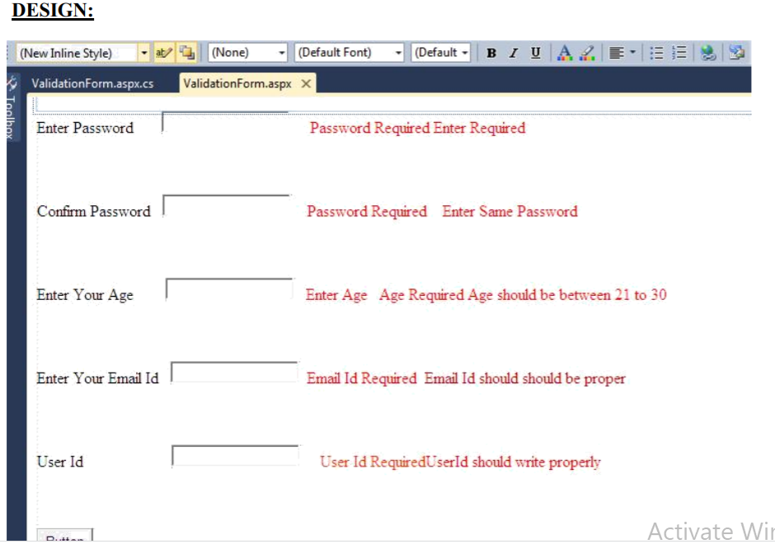

**Ans:--**

Aspx file

------------------------------------🡪>>>>>>

<%@ Page Language="C#" AutoEventWireup="true" CodeBehind="assign2.aspx.cs" Inherits="assign2.assign2" %>

<!DOCTYPE html>

<html xmlns="http://www.w3.org/1999/xhtml">

<head runat="server">

<title></title>

</head>

<body>

<form id="form1" runat="server">

<div>

<asp:Label ID="txtpass" runat="server" Text="Enter Password"></asp:Label>

&nbsp;

<asp:TextBox ID="txtpassword" runat="server" ></asp:TextBox>

&nbsp;

<asp:RequiredFieldValidator ID="RequiredFieldValidator1" runat="server" ControlToValidate="txtpassword" ErrorMessage="Enter Password" ForeColor="Red"></asp:RequiredFieldValidator>

<br />

&nbsp;<br />

<asp:Label ID="Label1" runat="server" Text="Confirm Password"></asp:Label>

&nbsp;

<asp:TextBox ID="txtcnf" runat="server"></asp:TextBox>

<asp:RequiredFieldValidator ID="RequiredFieldValidator2" runat="server" ControlToValidate="txtcnf" ErrorMessage="Password Required" ForeColor="Red"></asp:RequiredFieldValidator>

<asp:CompareValidator ID="CompareValidator1" runat="server" ControlToValidate="txtcnf" ControlToCompare="txtpassword" ErrorMessage="Password Must Be Same" ForeColor="#FF3300"></asp:CompareValidator>

<br />

<br />

<asp:Label ID="Label2" runat="server" Text="Enter Your Age"></asp:Label>

&nbsp;&nbsp;&nbsp;

<asp:TextBox ID="txtage" runat="server"></asp:TextBox>

&nbsp;<asp:RequiredFieldValidator ID="RequiredFieldValidator3" runat="server" ControlToValidate="txtage" ErrorMessage="Enter Your Age" ForeColor="#FF3300"></asp:RequiredFieldValidator>

<asp:RangeValidator ID="RangeValidator1" runat="server" ControlToValidate="txtage" ErrorMessage="Age Should Between 21 to 30" ForeColor="Red" MaximumValue="30" MinimumValue="21"></asp:RangeValidator>

<br />

<br />

</div>

<asp:Label ID="Label3" runat="server" Text="Enter Your Email Id"></asp:Label>

&nbsp;&nbsp;

<asp:TextBox ID="txtemail" runat="server"></asp:TextBox>

&nbsp;<asp:RequiredFieldValidator ID="RequiredFieldValidator4" runat="server" ControlToValidate="txtemail" ErrorMessage="Enter Your Email Id" ForeColor="#FF3300"></asp:RequiredFieldValidator>

<asp:RegularExpressionValidator ID="RegularExpressionValidator1" runat="server" ControlToValidate="txtemail" ErrorMessage="Email Should Be Proper" ForeColor="#FF3300" ValidationExpression="\w+([-+.']\w+)*@\w+([-.]\w+)*\.\w+([-.]\w+)*"></asp:RegularExpressionValidator>

<br />

<br />

<asp:Label ID="Label4" runat="server" Text="User Id"></asp:Label>

&nbsp;&nbsp;&nbsp;&nbsp;&nbsp;&nbsp;&nbsp;&nbsp;&nbsp;&nbsp;&nbsp;&nbsp;&nbsp;&nbsp;&nbsp;&nbsp;&nbsp;&nbsp;&nbsp;

<asp:TextBox ID="txtid" runat="server"></asp:TextBox>

&nbsp;<asp:RequiredFieldValidator ID="RequiredFieldValidator5" runat="server" ControlToValidate="txtid" ErrorMessage="Enter Your User Id" ForeColor="#FF3300"></asp:RequiredFieldValidator>

<asp:CustomValidator ID="CustomValidator1" runat="server" ErrorMessage="Your User Id Should Be Proper" OnServerValidate="CustomValidator1_ServerValidate"></asp:CustomValidator>

<br />

<br />

<br />

&nbsp;&nbsp;&nbsp;&nbsp;&nbsp;&nbsp;&nbsp;&nbsp;&nbsp;&nbsp;&nbsp;&nbsp;&nbsp;&nbsp;&nbsp;&nbsp;&nbsp;&nbsp;&nbsp;&nbsp;&nbsp;&nbsp;&nbsp;

<asp:Button ID="txtlog" runat="server" Text="Log In" />

<br />

<br />

</form>

</body>

</html>

Aspx.cs File:

--------------------------------------------------------------🡪>>>>

using System;

using System.Collections.Generic;

using System.Linq;

using System.Web;

using System.Web.UI;

using System.Web.UI.WebControls;

namespace assign2

{

public partial class login : System.Web.UI.Page

{

protected void Page_Load(object sender, EventArgs e)

{

}

protected void CustomValidator1_ServerValidate(object source, ServerValidateEventArgs args)

{

string str = args.Value;

args.IsValid = false;

if (str.Length < 7 || str.Length > 20)

{

return;

}

bool capital = false;

foreach (char ch in str)

{

if (ch >= 'A' && ch <= 'Z')

{

capital = true;

break;

}

}

if (!capital)

return;

bool digit = false;

foreach (char ch in str)

{

if (ch >= '0' && ch <= '9')

{

digit = true;

break;

}

}

if (!digit)

return;

args.IsValid = true;

}

}

}

3. Write a program using function overloading to swap two integer numbers and

swap two float numbers.

Ans:---

using System;

class Poulami

{

public void Swap(int a, int b)

{

a = a + b;

b = a - b;

a = a - b;

Console.WriteLine(a);

Console.WriteLine(b);

}

public void Swap(float a, float b)

{

a = a + b;

b = a - b;

a = a - b;

Console.WriteLine(a);

Console.WriteLine(b);

}

public static void Main()

{

Poulami d=new Poulami();

d.Swap(10 ,20);

d.Swap(10.50f, 20.21f);

}

}

4.Write a program to accept a number from the user and throw an exception if

the number is not an even number.

Ans:----------------

using System;

class Poulami

{

public static void Main()

{

try

{

int x=int.Parse(Console.ReadLine());

if(x%2>0)

{

throw new ApplicationException("This no is not an even number");

}

Console.WriteLine(x);

}

catch(Exception ex)

{

Console.WriteLine(ex.ToString());

}

}

}

5: List of employees is available in listbox. Write an application to add selected or all

records from listbox (assume multi-line property of textbox is true).

DESIGN:

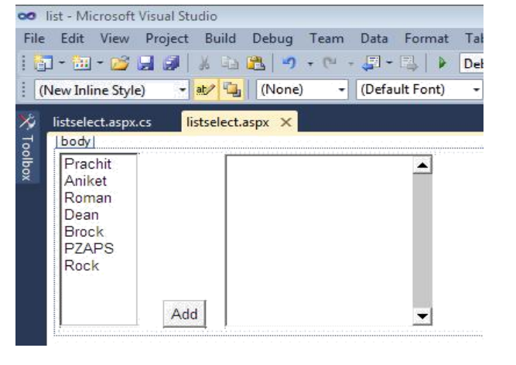

Ans:--

Aspx File

------------------------------------------------------------------------🡪>>>>>>

<%@ Page Language="C#" AutoEventWireup="true" CodeBehind="assign3.aspx.cs" Inherits="assgin3.assign3" %>

<!DOCTYPE html>

<html xmlns="http://www.w3.org/1999/xhtml">

<head runat="server">

<title></title>

<style type="text/css">

#TextArea1 {

width: 275px;

height: 141px;

margin-top: 0px;

}

#txtlst {

margin-top: 0px;

}

</style>

</head>

<body>

<form id="form1" runat="server">

<div>

<asp:ListBox ID="txtemp" runat="server">

<asp:ListItem Value="Debjit Purkaite"></asp:ListItem>

<asp:ListItem>Shyamsundar De</asp:ListItem>

<asp:ListItem>Subhodeep Dey</asp:ListItem>

<asp:ListItem Value="Souvik Ghosh">Souvik Ghosh</asp:ListItem>

<asp:ListItem>Kushol Chakrobarty</asp:ListItem>

<asp:ListItem>Mriyom Banarjee</asp:ListItem>

<asp:ListItem>Vishal Jadav</asp:ListItem>

<asp:ListItem>Tania Ghosh</asp:ListItem>

<asp:ListItem>Poulami Dhar</asp:ListItem>

</asp:ListBox>

&nbsp;&nbsp;&nbsp;&nbsp;&nbsp;&nbsp;&nbsp;

<asp:TextBox ID="txtlst" runat="server" Height="120px" TextMode="MultiLine"></asp:TextBox>

&nbsp;&nbsp;&nbsp;&nbsp;&nbsp;&nbsp;&nbsp;&nbsp;&nbsp;&nbsp;&nbsp;&nbsp;&nbsp;&nbsp;&nbsp;&nbsp;

<br />

&nbsp;<br />

&nbsp;&nbsp;&nbsp;&nbsp;&nbsp;&nbsp;&nbsp;&nbsp;&nbsp;&nbsp;&nbsp;&nbsp;&nbsp;&nbsp;&nbsp;&nbsp;&nbsp;&nbsp;&nbsp;&nbsp;&nbsp;&nbsp;&nbsp;&nbsp;&nbsp;&nbsp;&nbsp;&nbsp;&nbsp;&nbsp;&nbsp;&nbsp;&nbsp;&nbsp;&nbsp;&nbsp;&nbsp;&nbsp;&nbsp;

<asp:Button ID="txtadd" runat="server" OnClick="txtadd_Click" Text="Add" />

&nbsp;&nbsp;

</div>

</form>

</body>

</html>

Aspx.cs File

--------------------------------------------------------------------------------------🡪>>>>>>>>>>

using System;

using System.Collections.Generic;

using System.Linq;

using System.Web;

using System.Web.UI;

using System.Web.UI.WebControls;

namespace assgin3

{

public partial class assign2 : System.Web.UI.Page

{

protected void Page_Load(object sender, EventArgs e)

{

}

protected void txtadd_Click(object sender, EventArgs e)

{

int i;

for (i = 0; i < txtemp.Items.Count; i++)

{

if (txtemp.Items[i].Selected == true)

txtlst.Text += txtemp.Items[i].Text+"\n";

}

}

}

}

